Cairo University Faculty of Computers and Information



**CS352 – Software Engineering II**

**Software design specification document**

**2019**

**Project Team**

|  |  |  |  |
| --- | --- | --- | --- |
| **ID** | **Name** | **Email** | **Mobile** |
| 20160140 | AbdAllah Saeed AbdElhameed | khalifaabdallah101@gmail.com | 01550095471 |
| 20160145 | AbdElsalam Mohamed Mahmoud | abdelsalammohamed@stud.fci-cu.edu.eg | 01111876348 |
| 20160209 | Mohamed Shaaban Abdelhaseeb | mhegazy22111998@gmail.com | 01120700027 |

**Eng. Nehal**

Contents

Class diagram design 2

Entity Relationship Diagram 3

Github repository link 3

Trello workspace...................................................................................................................................3

# Class diagram design

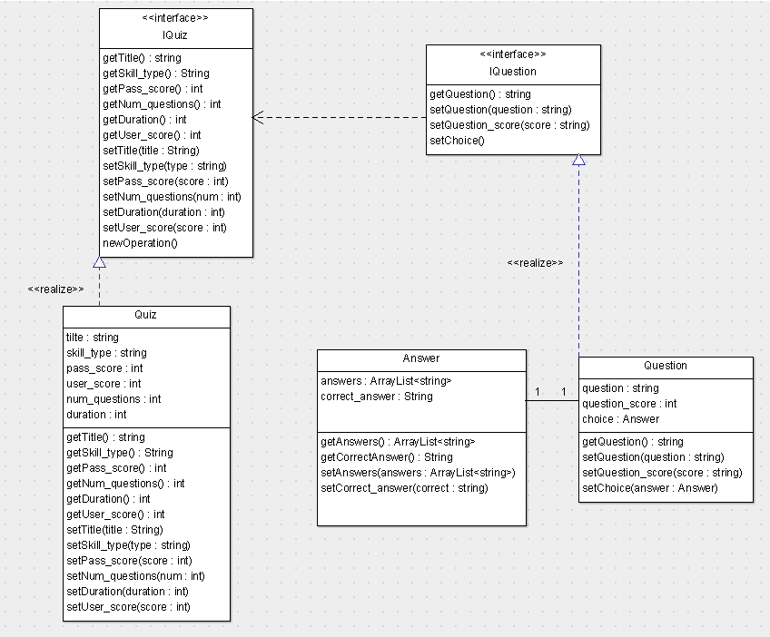

# Entity Relationship Diagram

# 

# Github repository link

***https://github.com/AbdElsalamMohammed/Quiz***

**Trello workspace**

***https://trello.com/swe2project1/***